**Lab 7: Deep Freeze**

**Course Name**: Malware Analysis and Reverse Engineering (IAM302)

**Student Name**: Nguyễn Trần Vinh – SE160258

**Instructor Name**: Mai Hoàng Đỉnh

**Lab Due Date**: 1/2/2023

**Purpose:**

Configuring a Malware Lab Manipulating HTTP/HTTPS with Burp Suite Using Deep Freeze to Preserve Physical Systems

**What we need:**

- VMWARE is not freely available open source software

- 6 network modes are available

* Not attached, NAT, Bridged Adapter, Internal Network, Host only Adapter, Generic Driver

**VMWARE WorkStation**

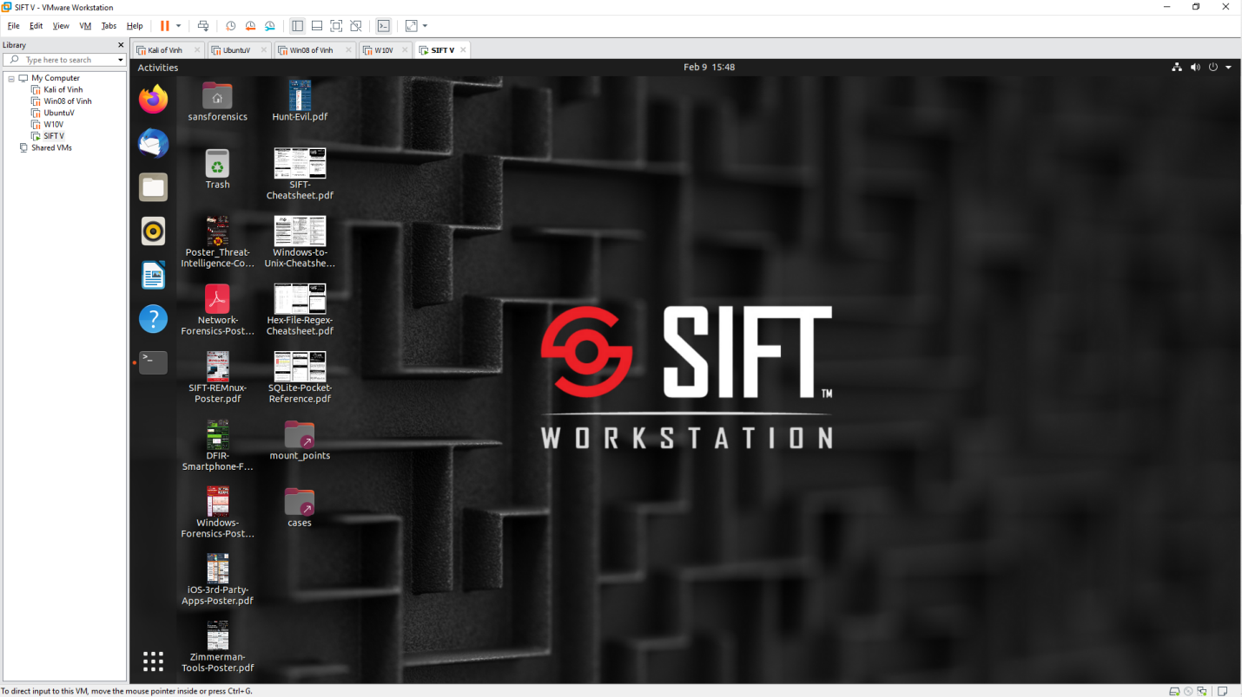

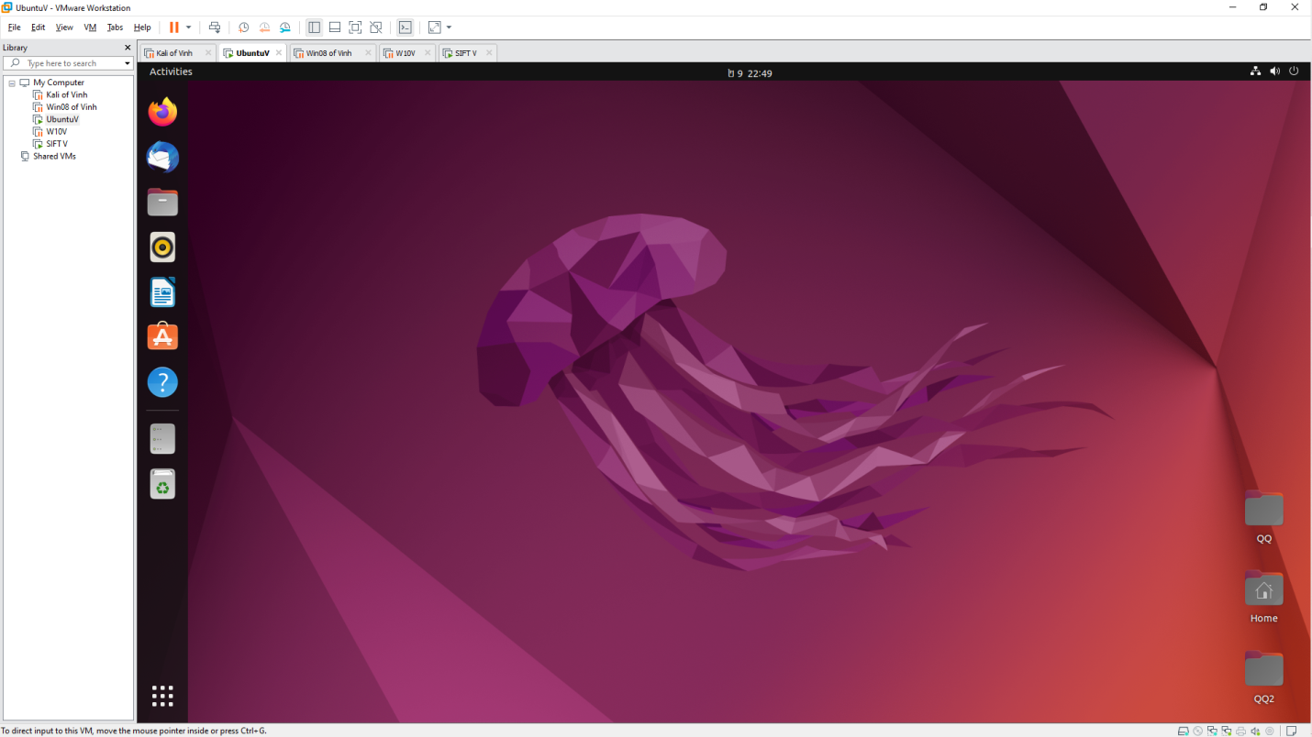

**Configurations of NETWORK on vmware workstation**

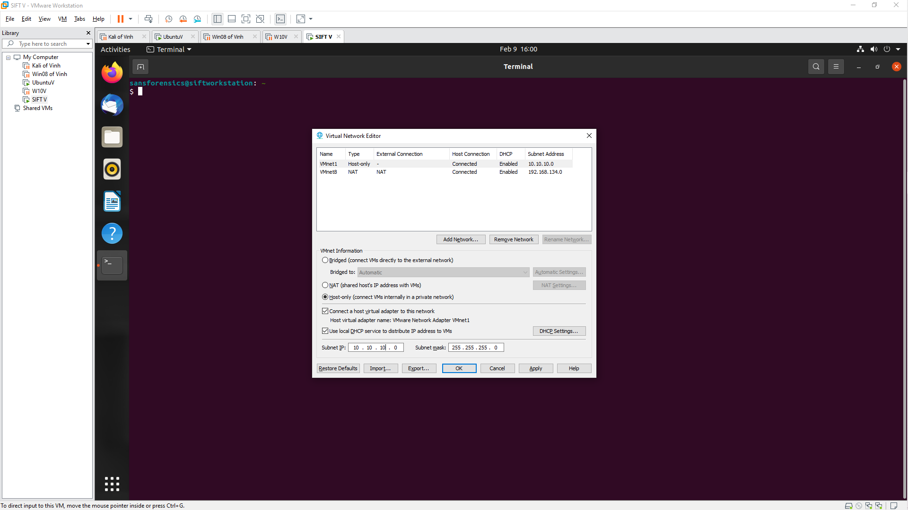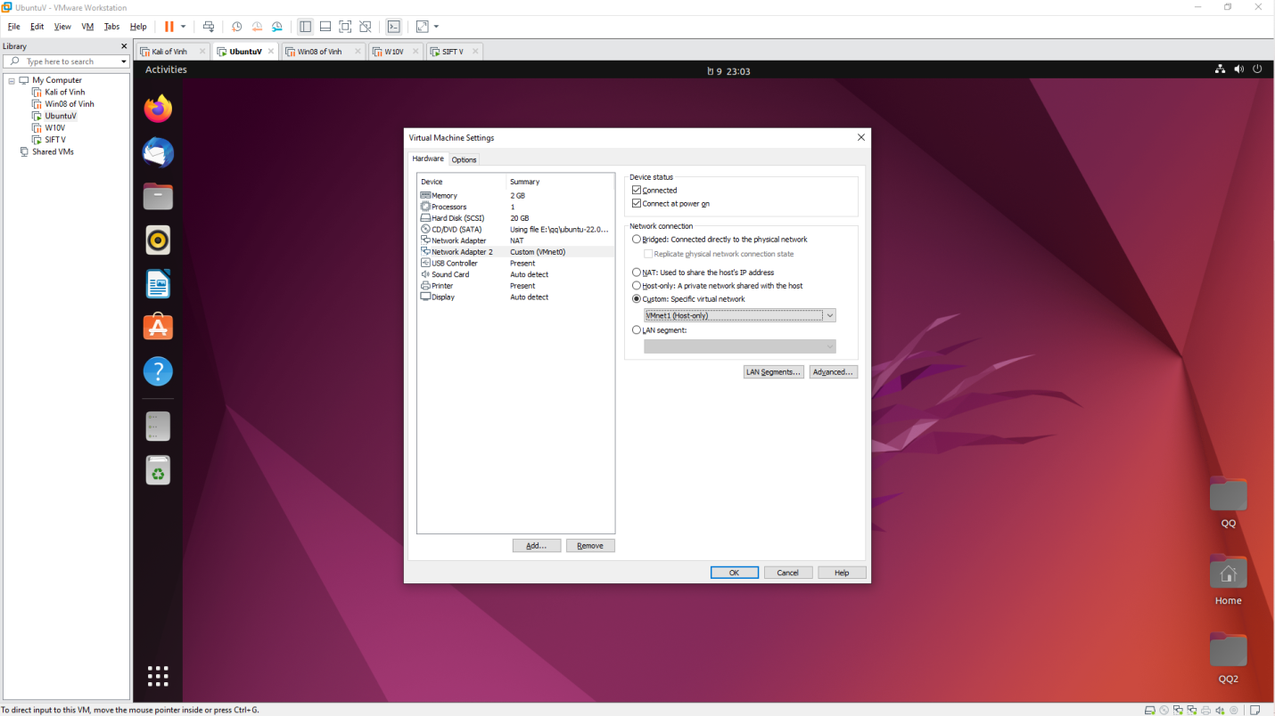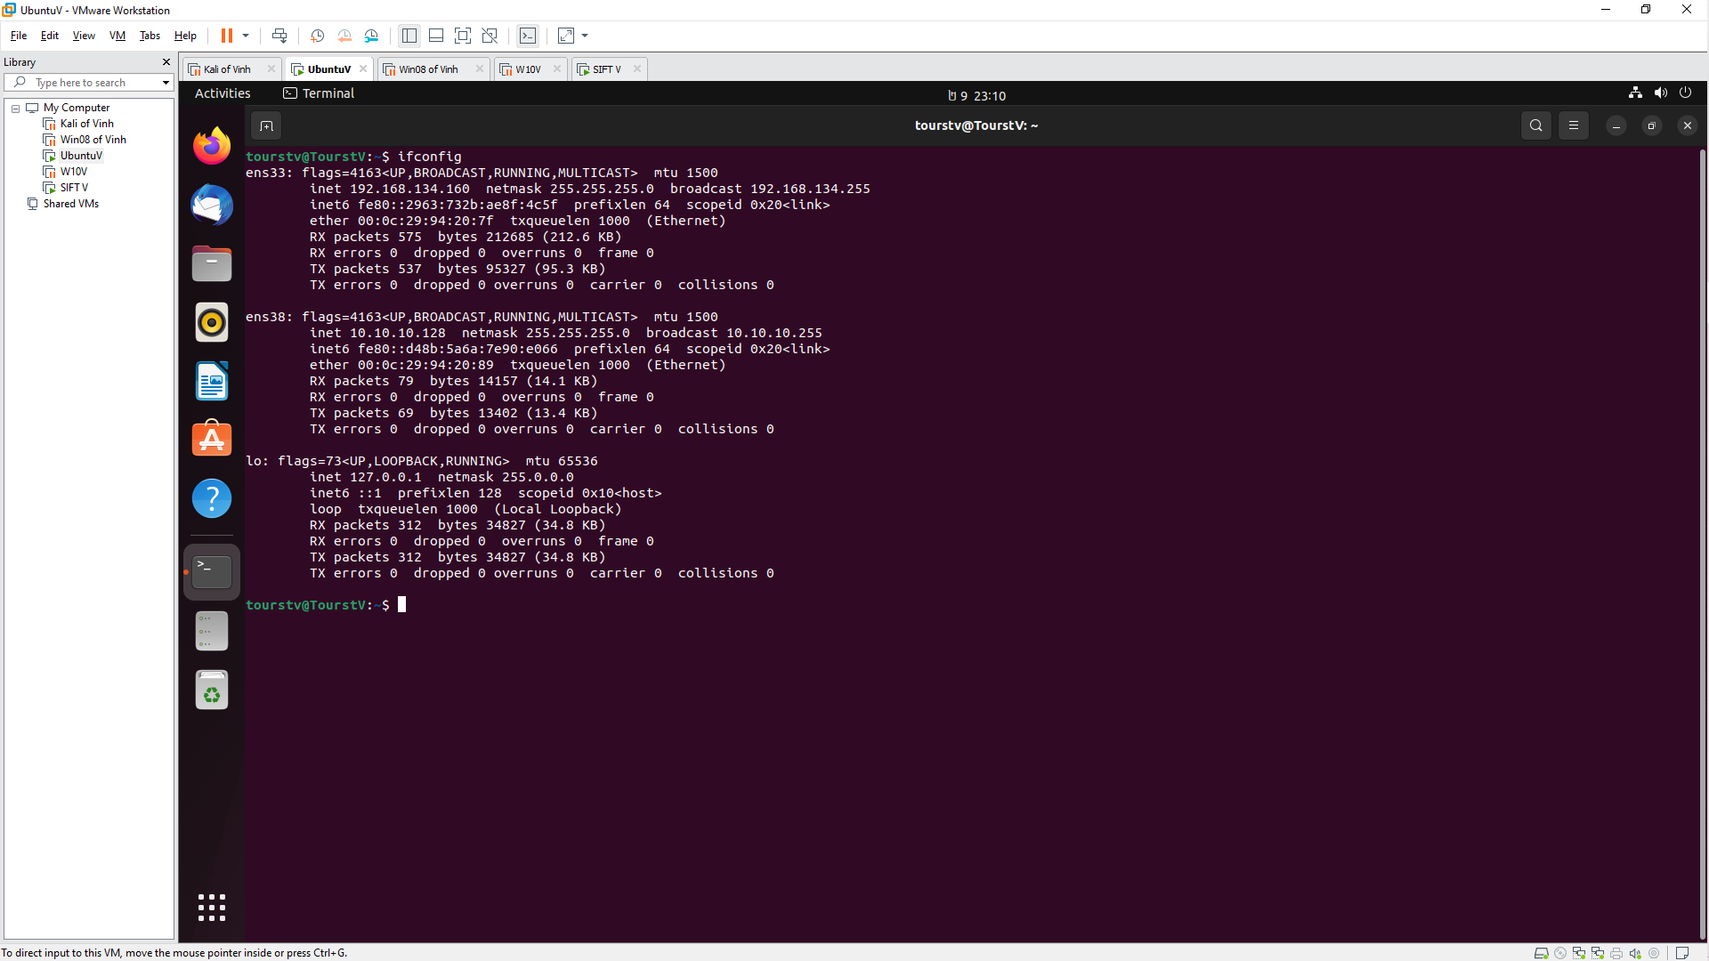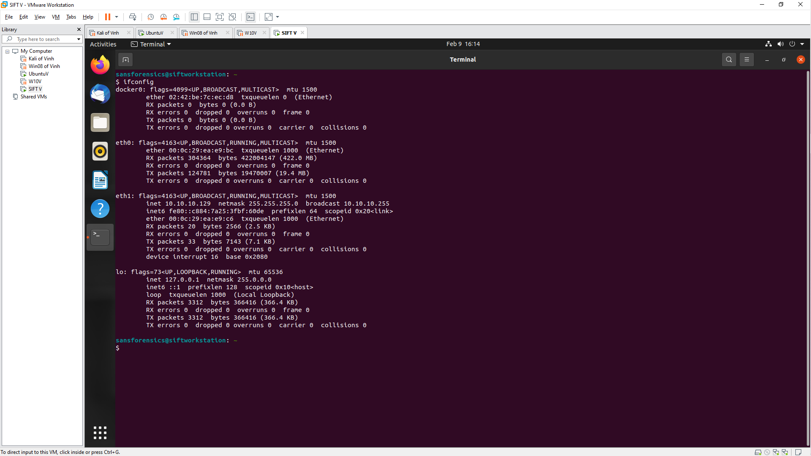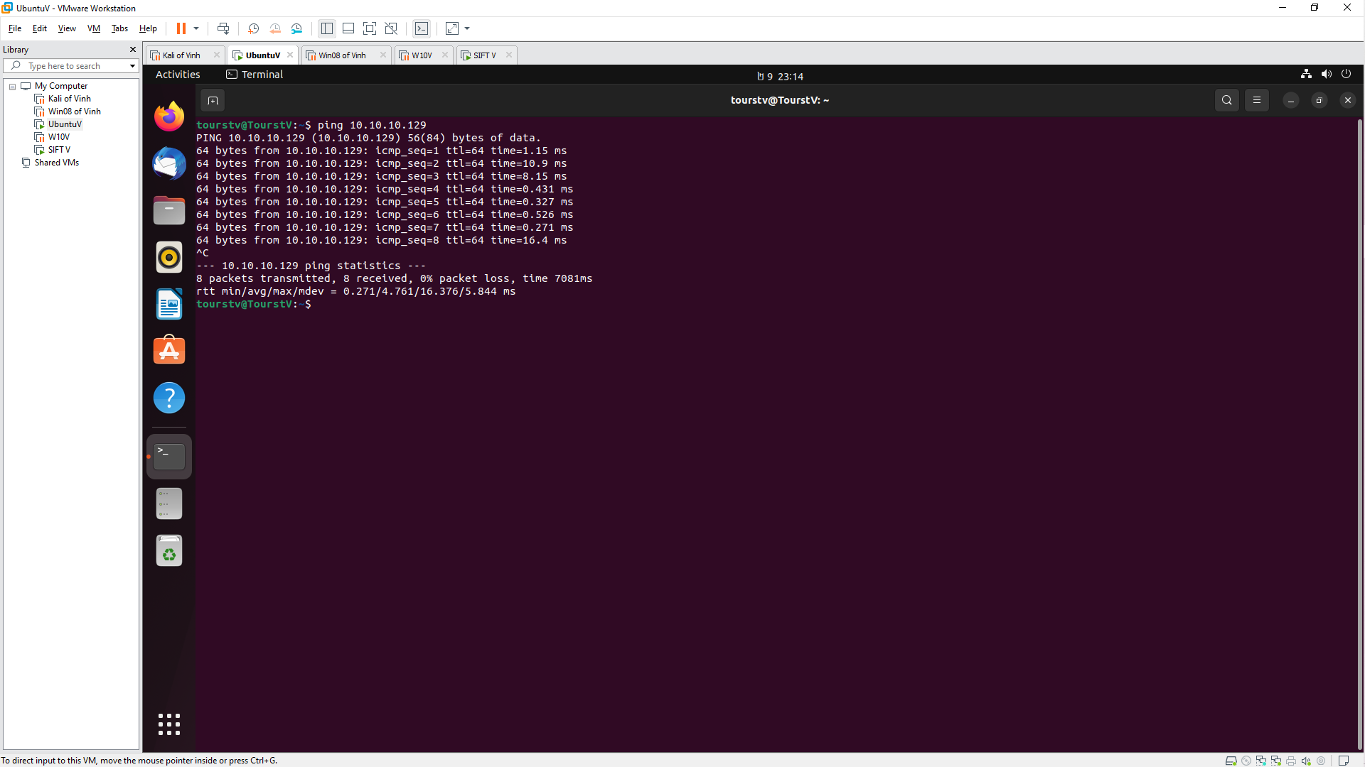

**Install WireShark**

- WireShark

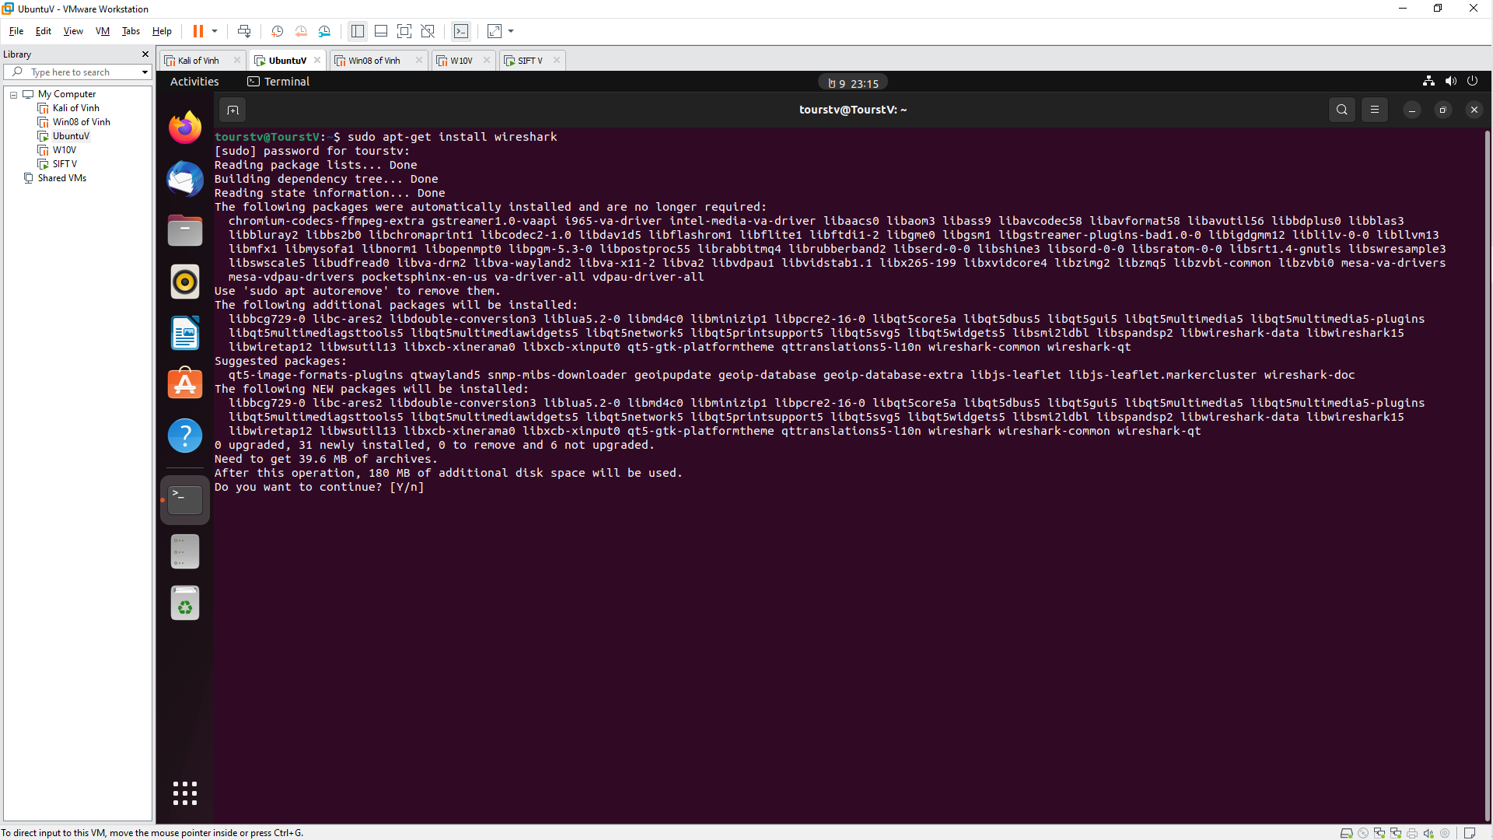

- tshark

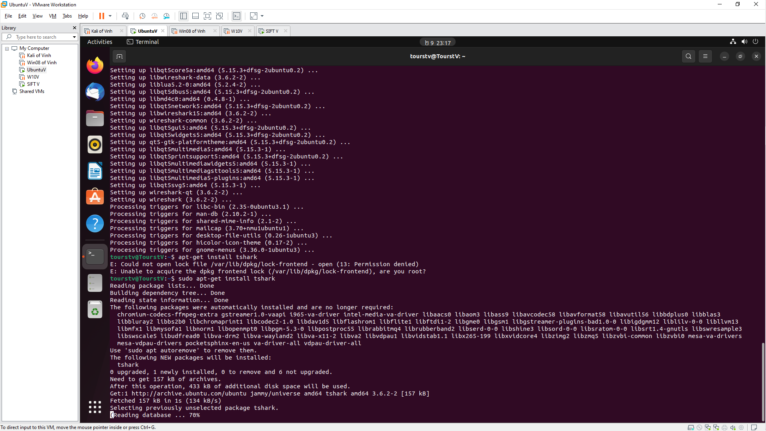**-** choose ens38

**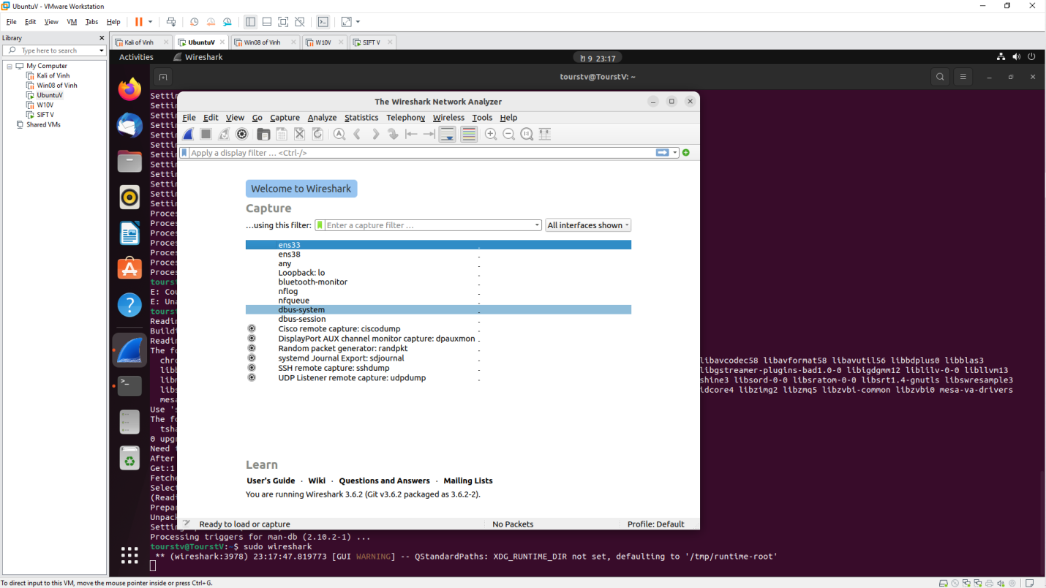  
CAPTURE PACKET BY WIRESHARK**

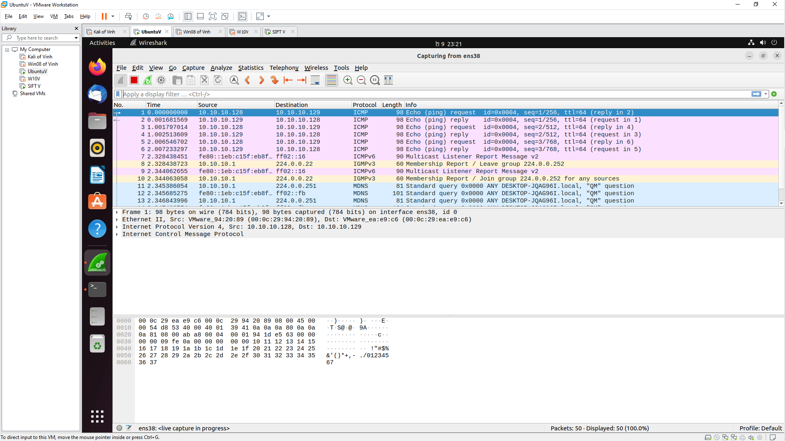

**-** Conversation

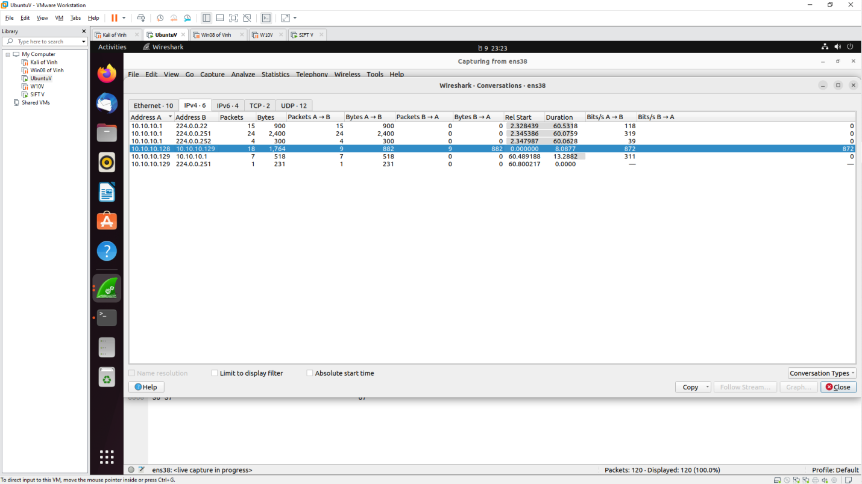

**Install InetSim**

Install:

apt-get install libnet-server-perl

apt-get install libnet-dns-perl

apt-get install libipc-shareable-perl

apt-get install libdigest-sha-perl

apt-get install libio-socket-ssl-perl

apt-get install iptables-dev

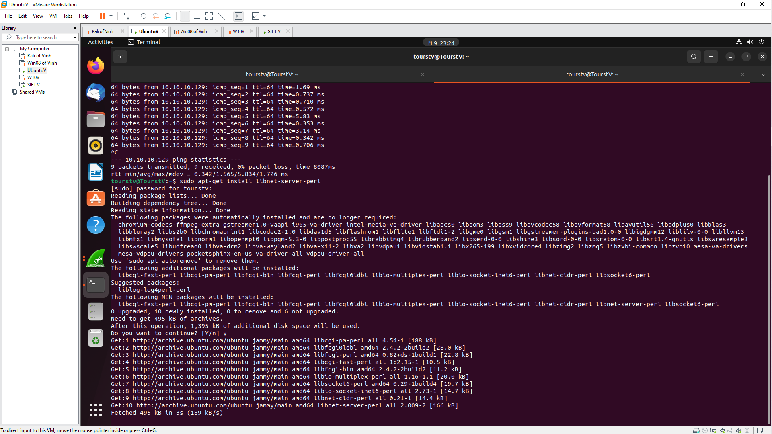

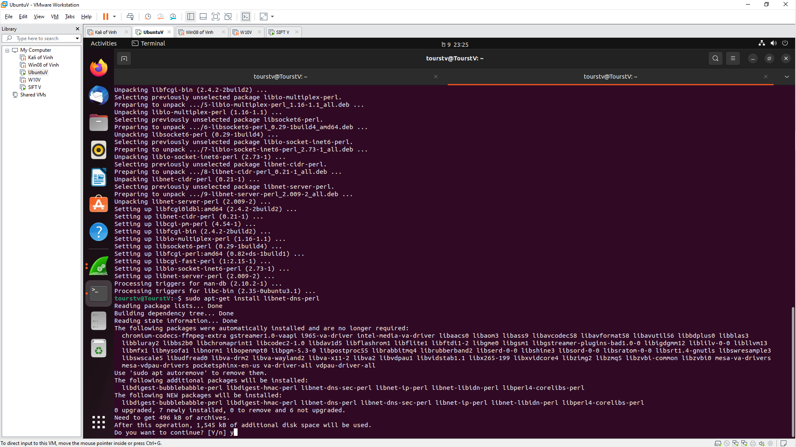

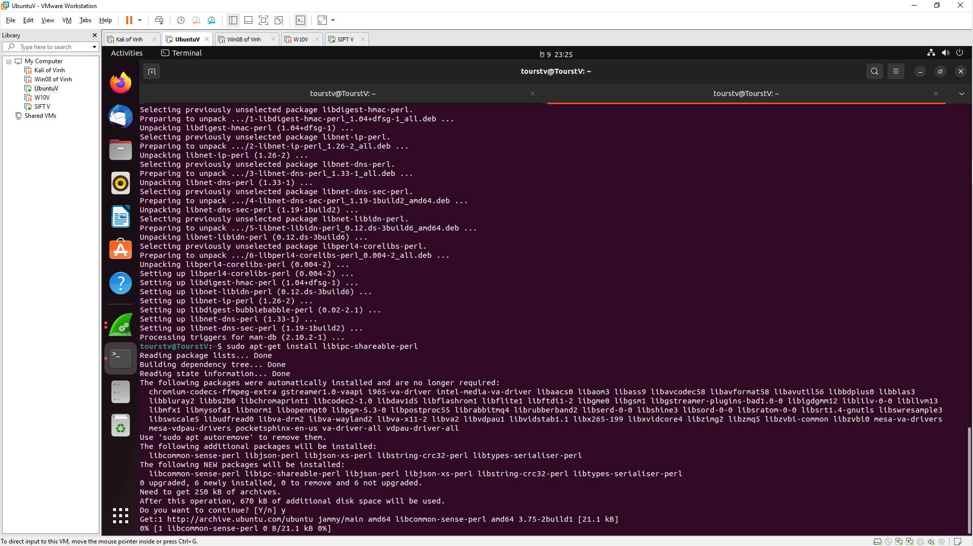

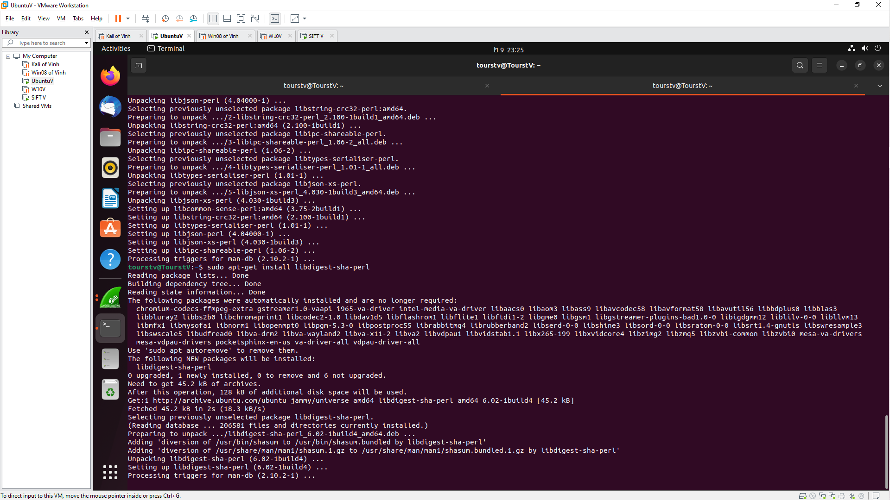

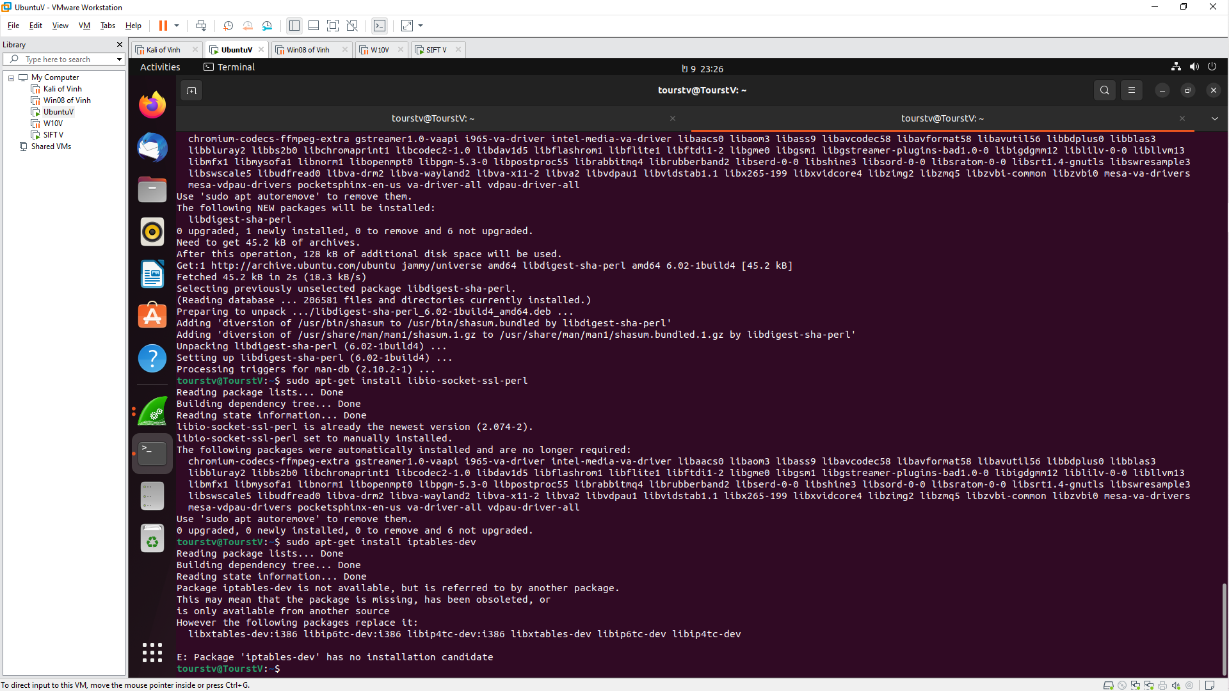

Dowload the INetSim

dpkg -i inetsim_1.2.4-1_all.deb

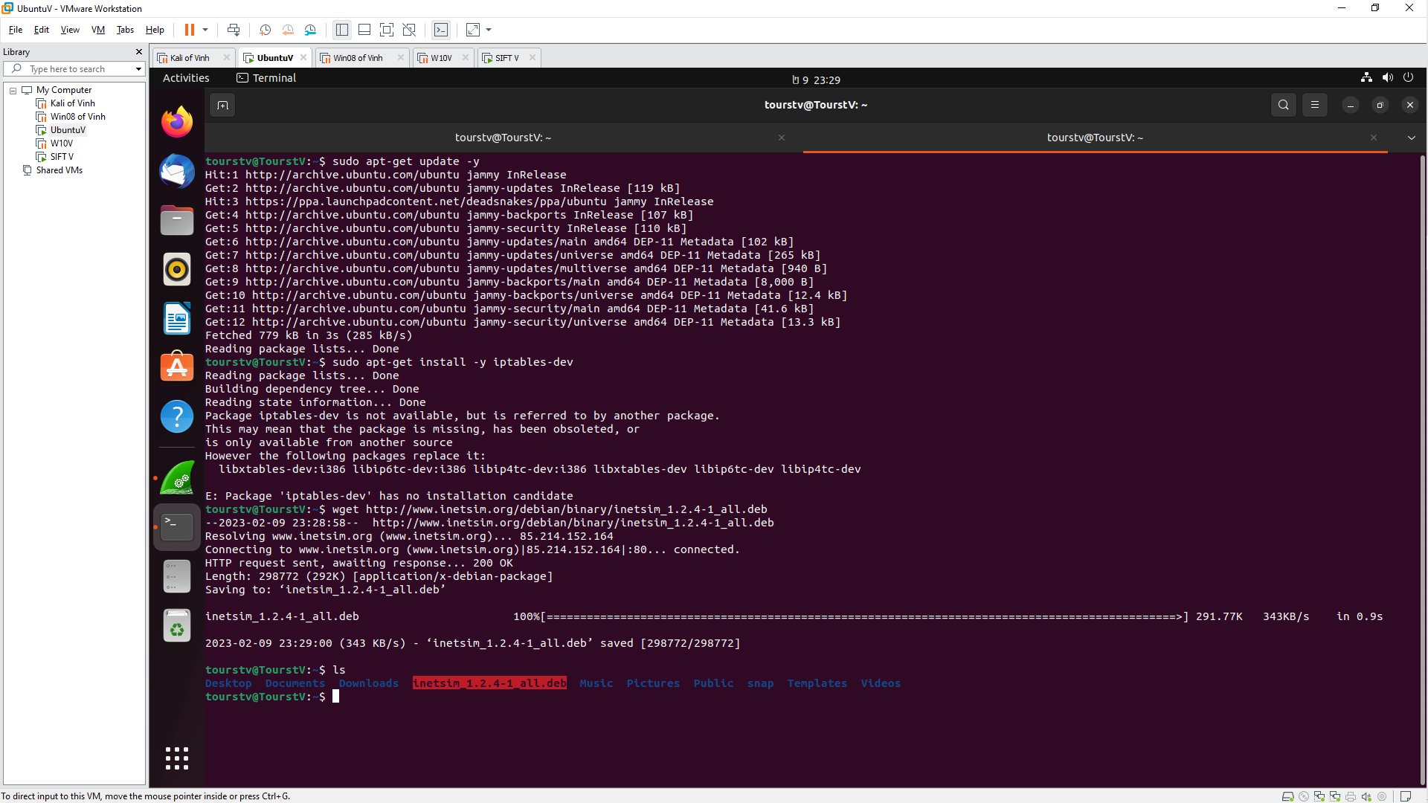 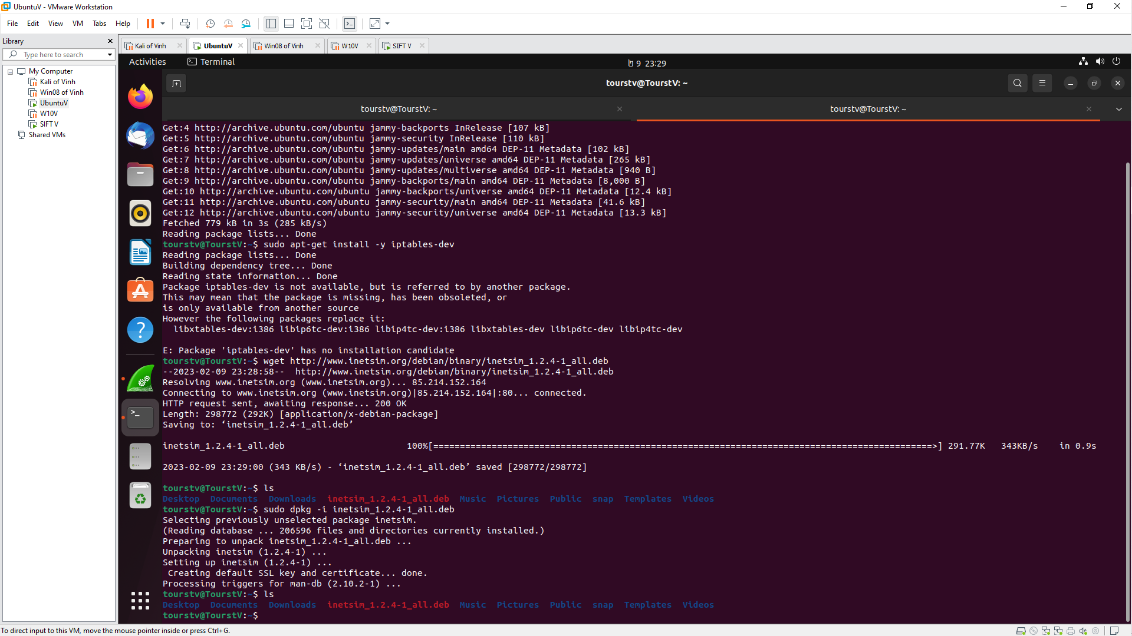

**-** Configurtion in /etc/inetsim/inetsim.conf 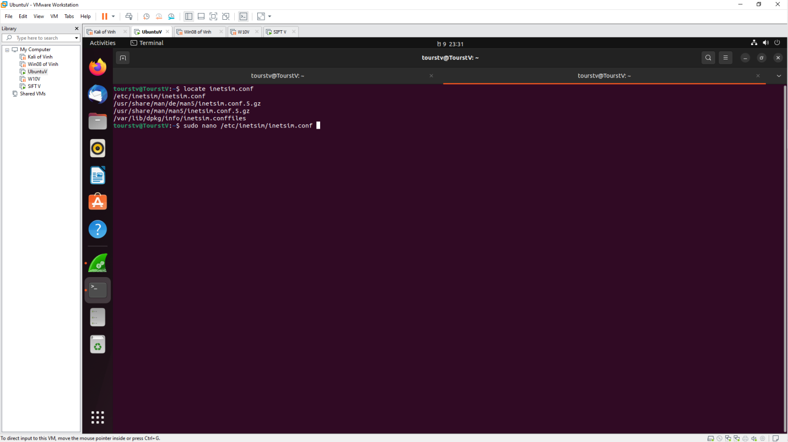

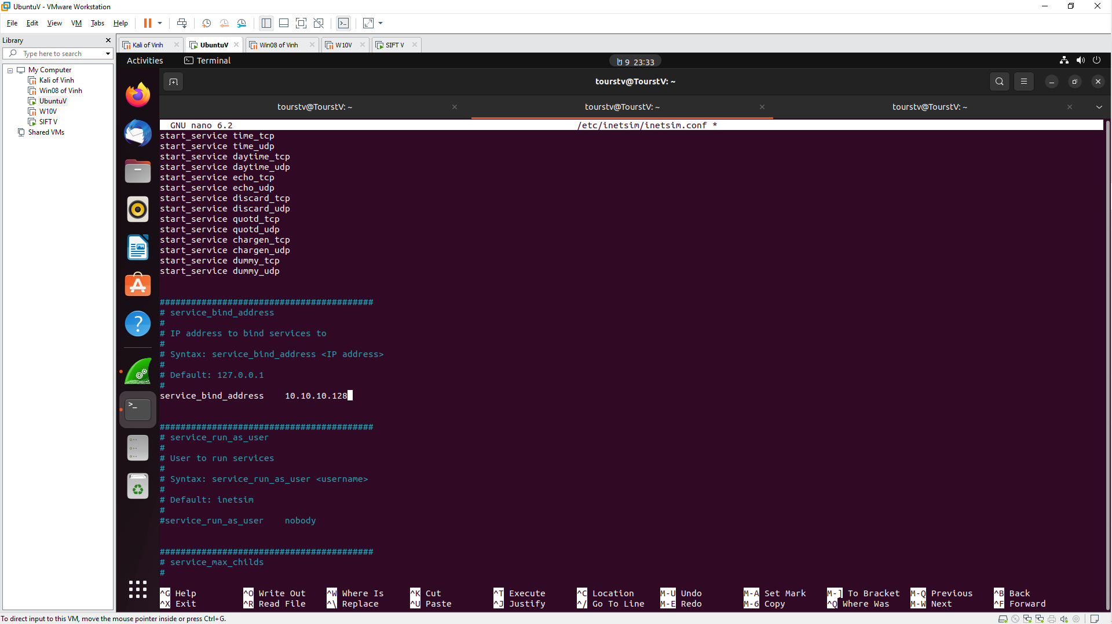

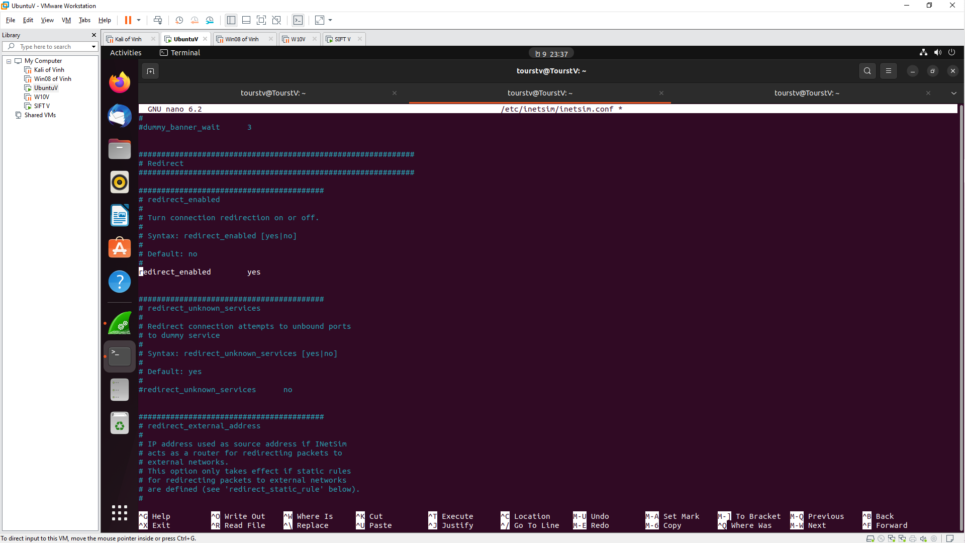 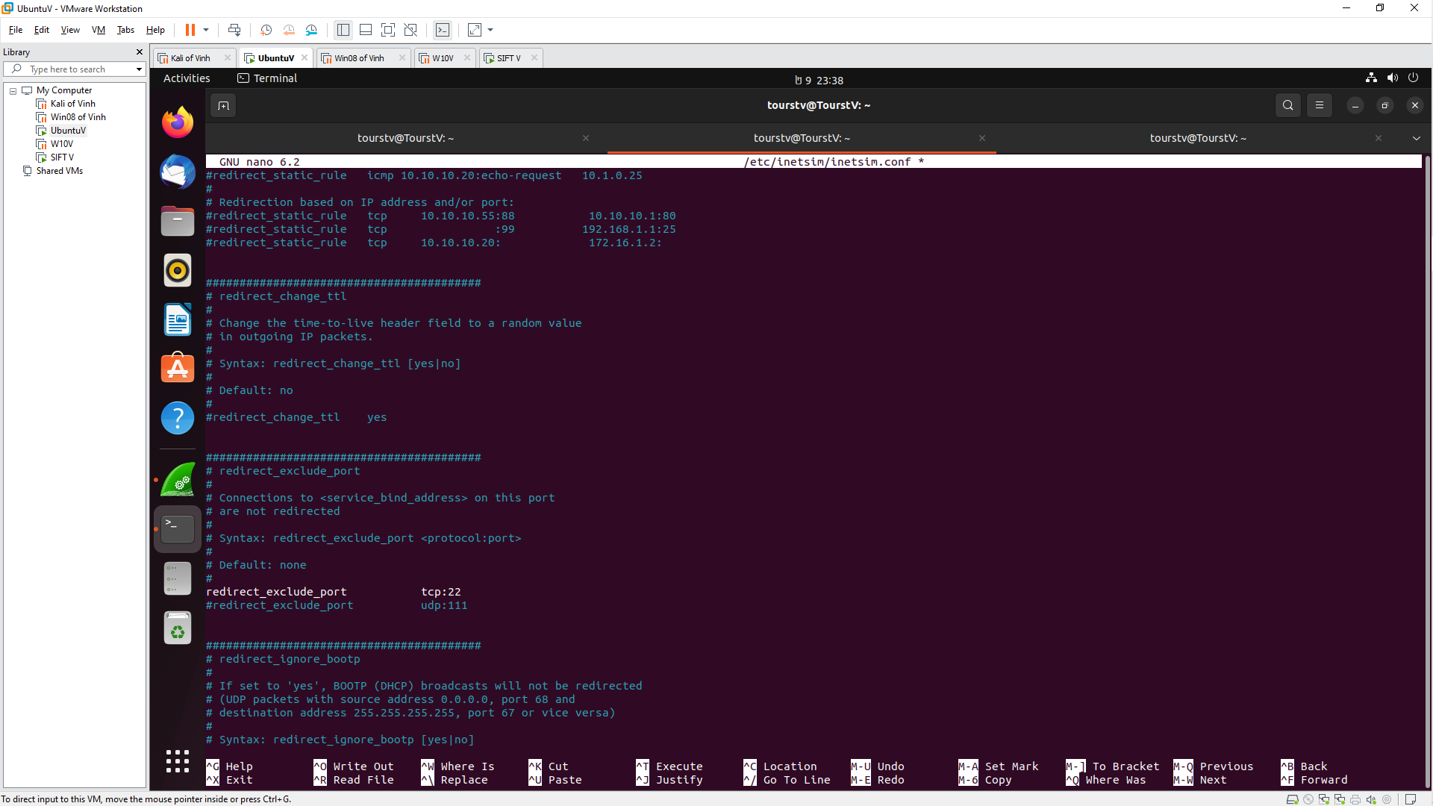

**sudo inetsim**

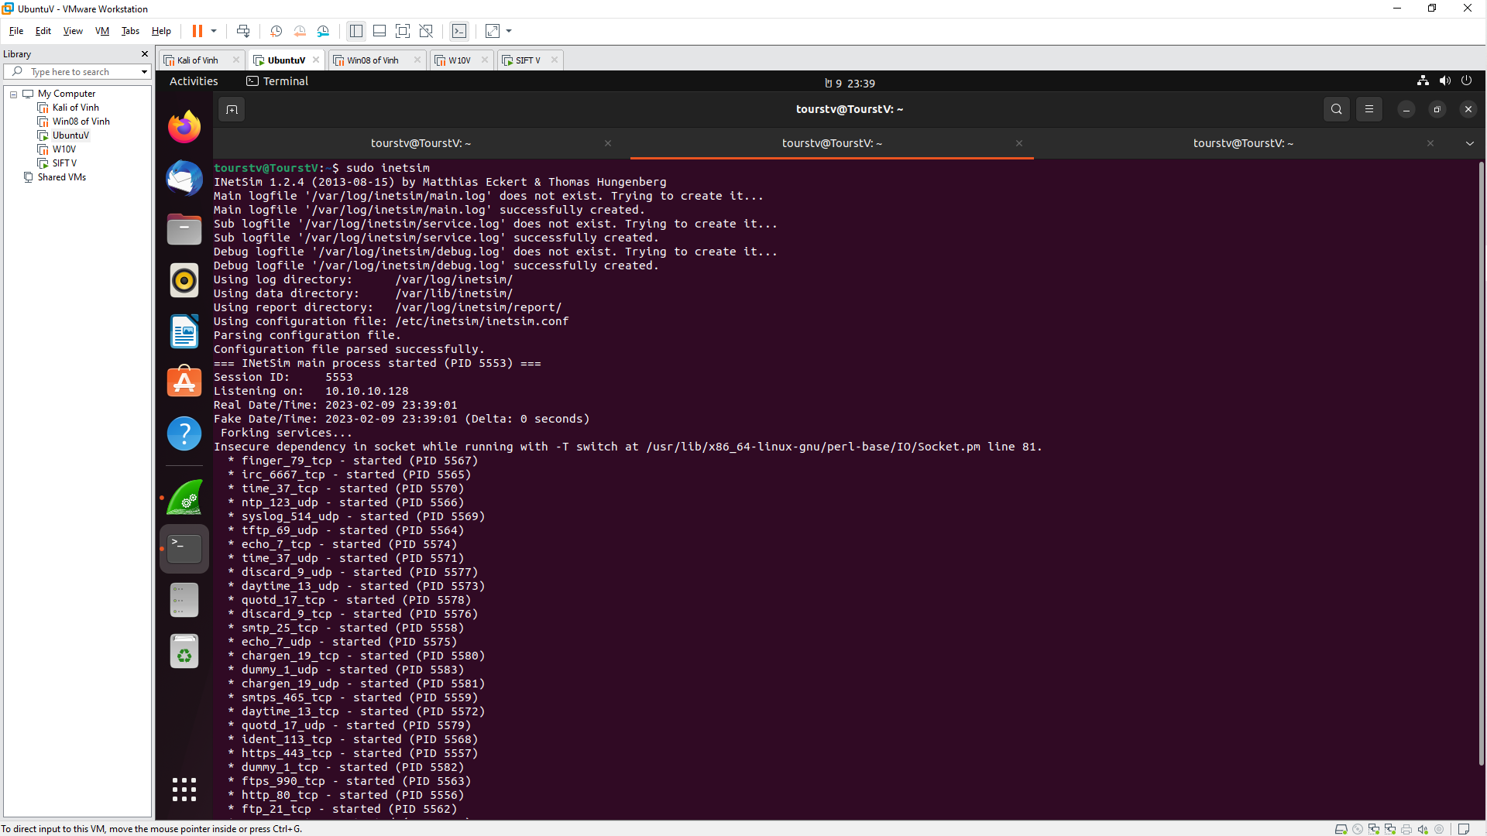

**Install Burp Suite**

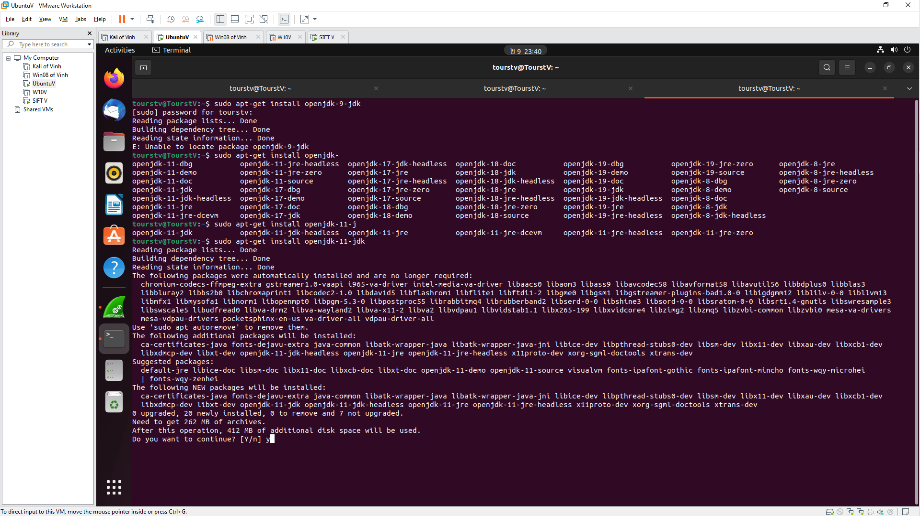 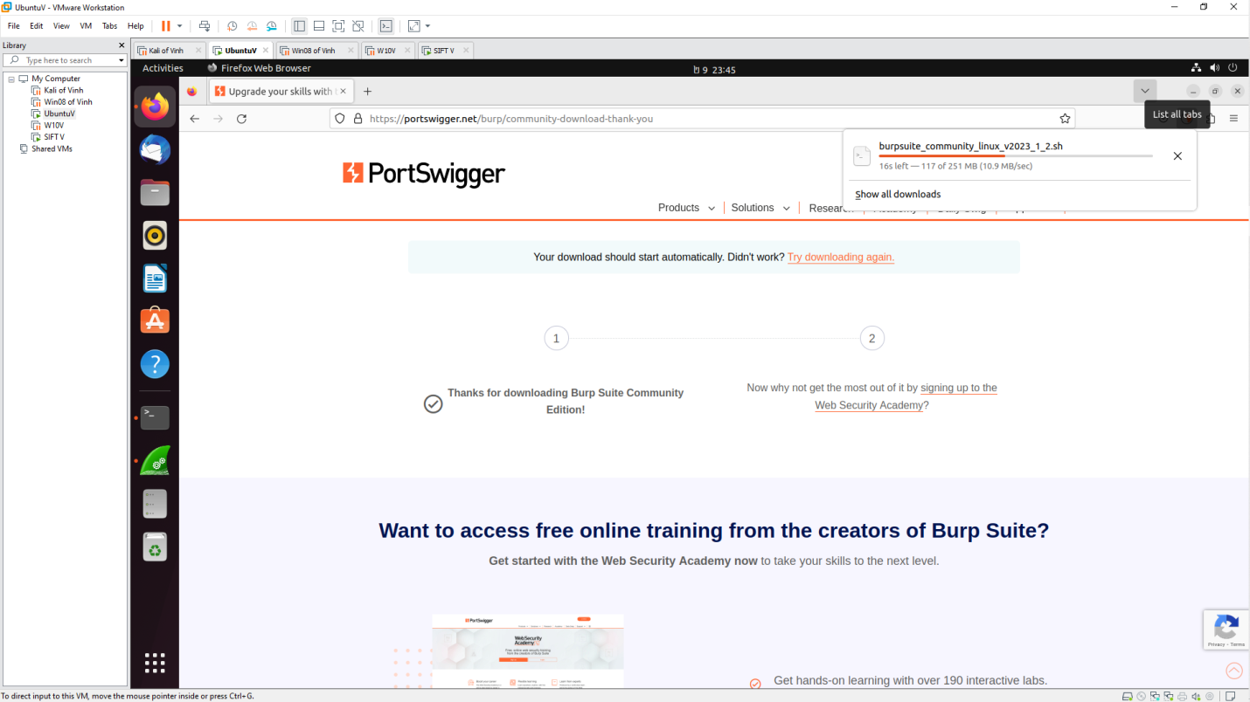

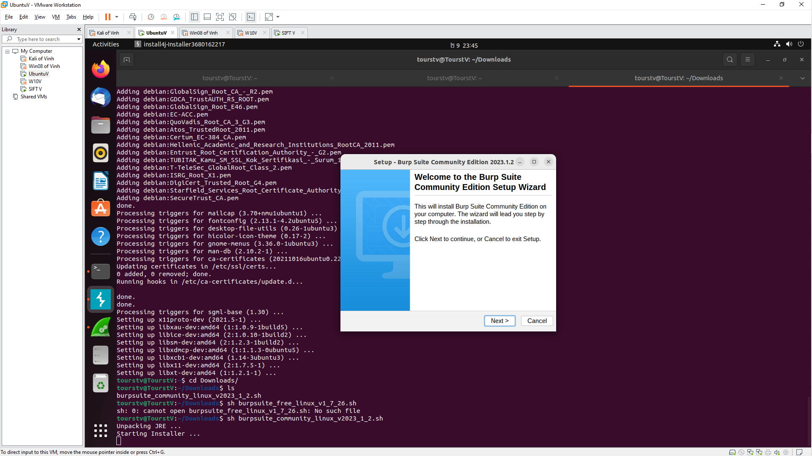 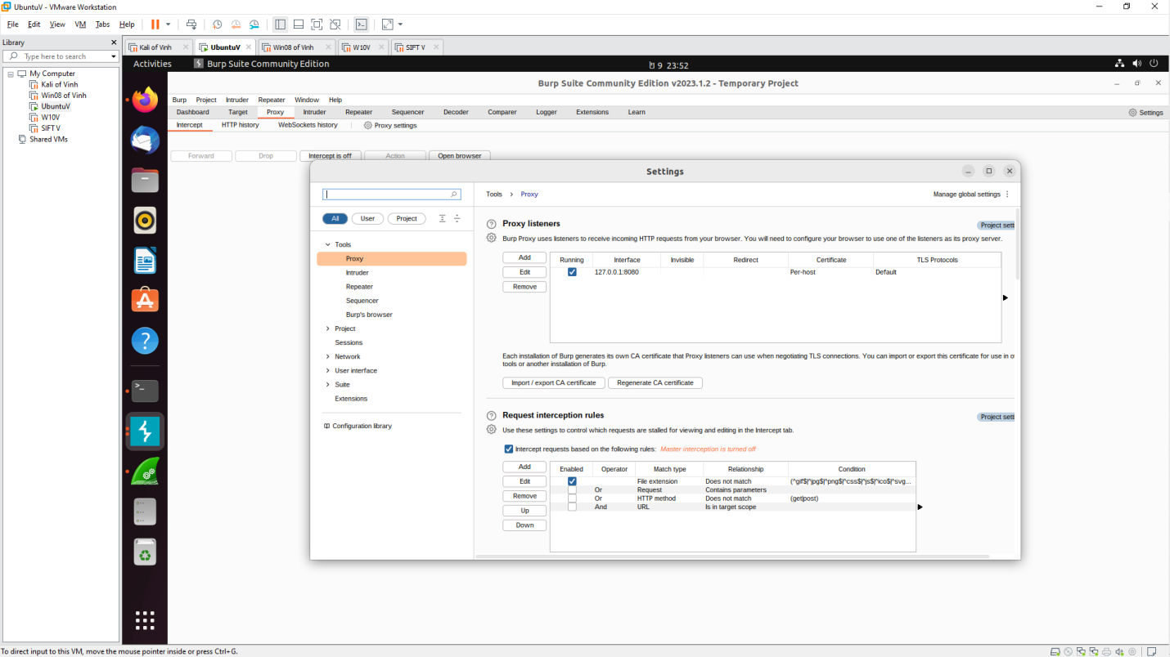 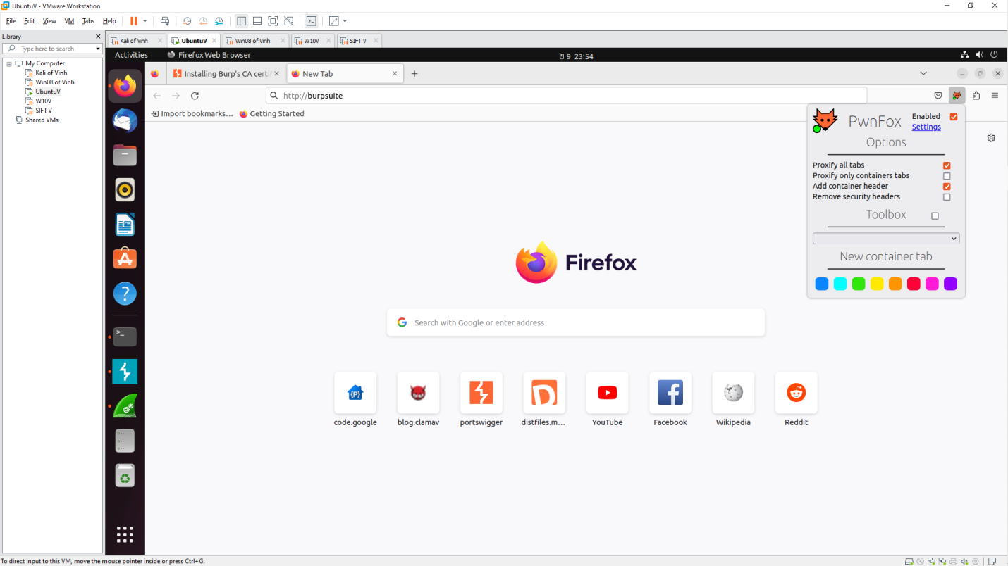 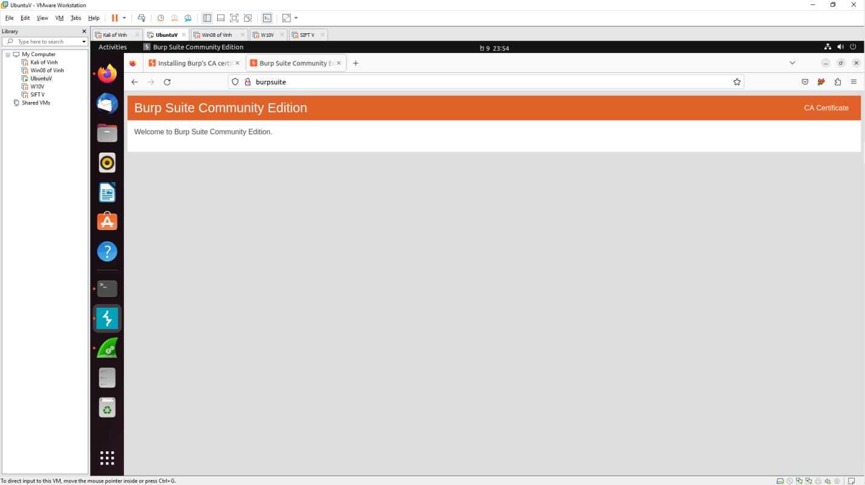

**WORKSHOP1**

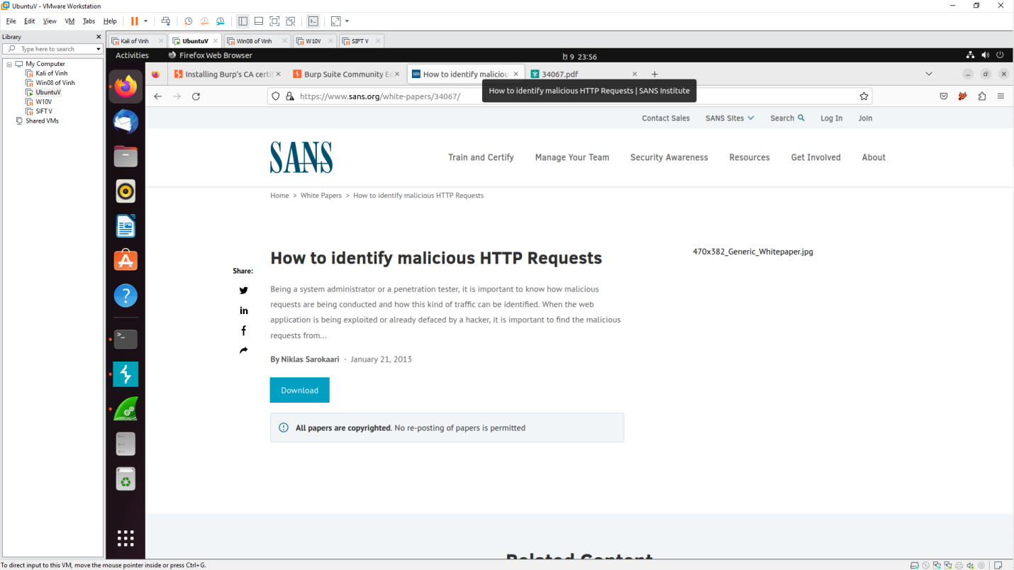

**Using hydra to Bruteforce**

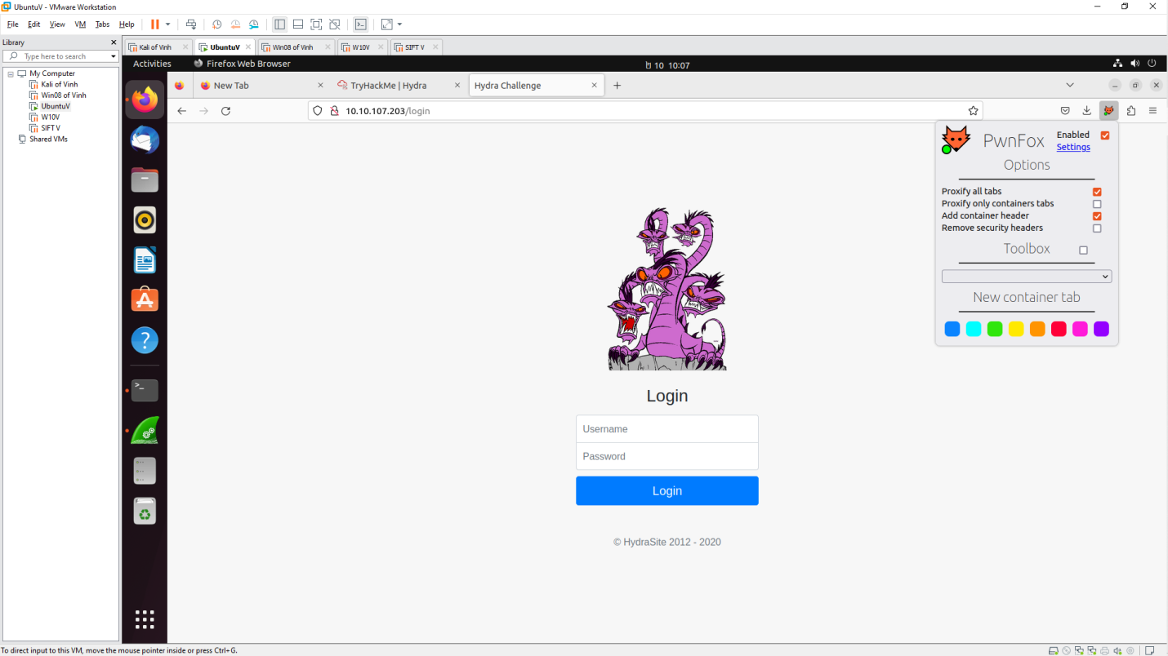

- login with ‘admin@admin’

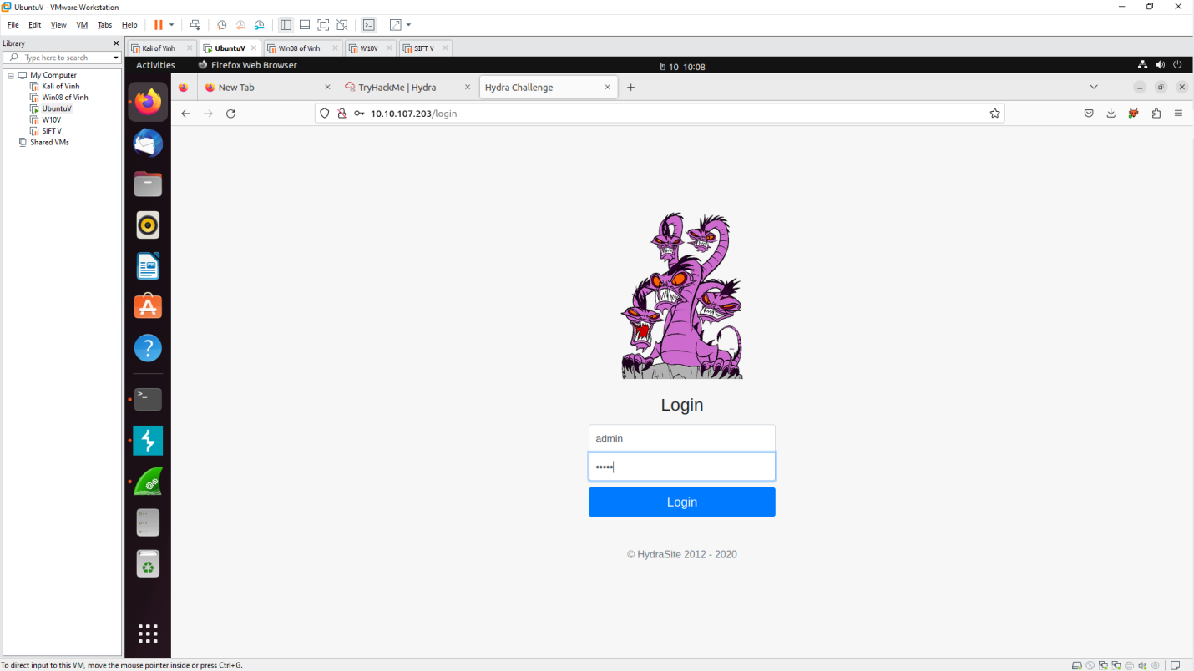

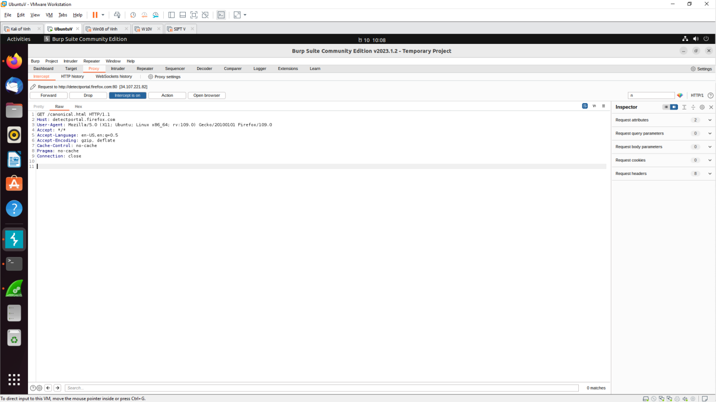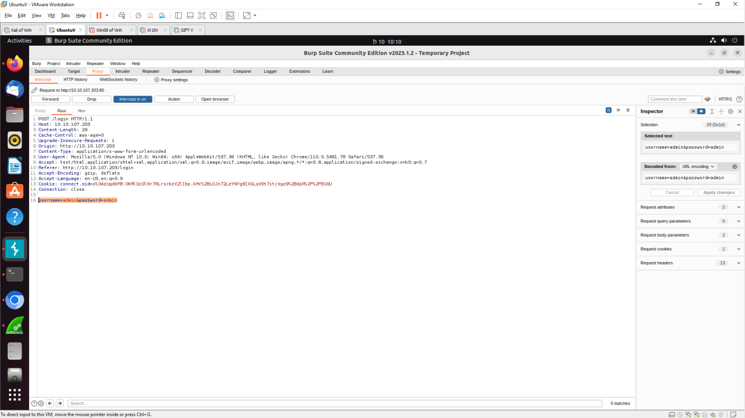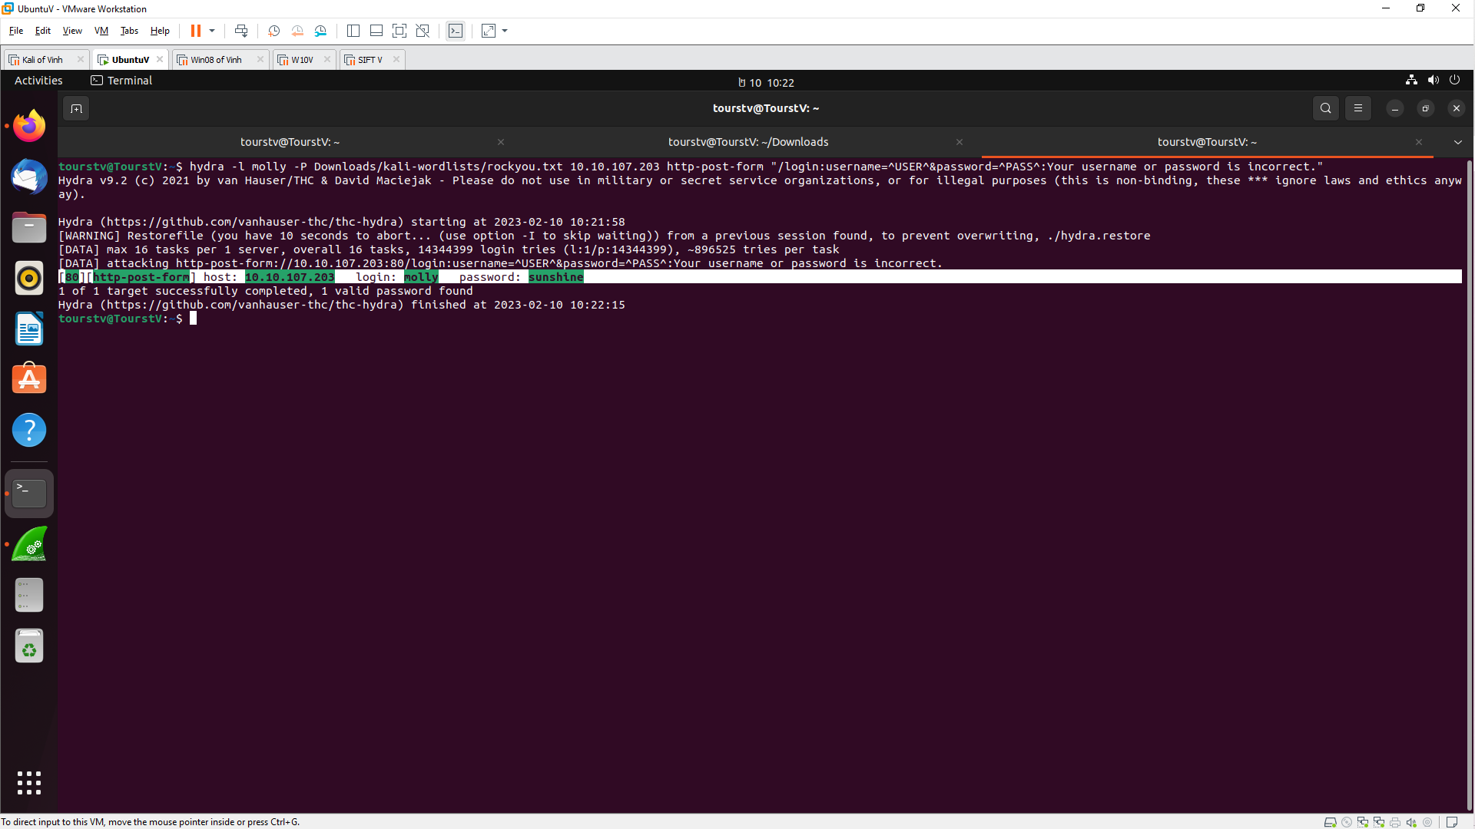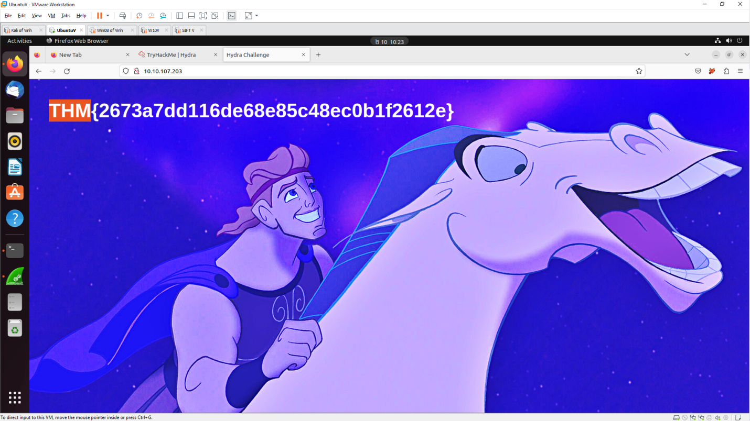

**WORKSHOP2**

Which systems (i.e. IP addresses) are involved?

- 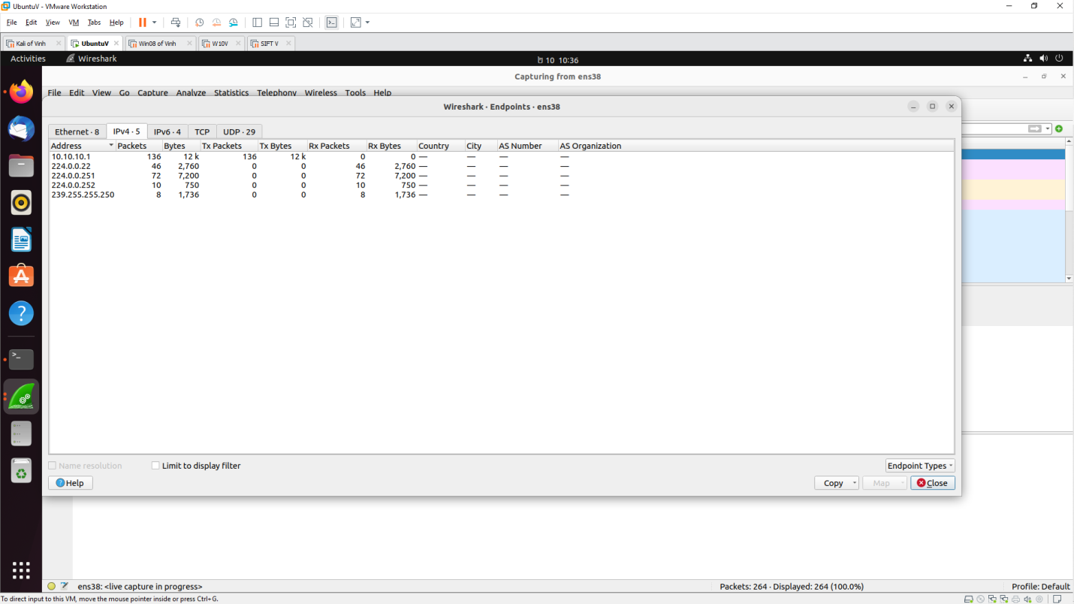

- What can you find out about the attacking host (e.g., where is it located)?

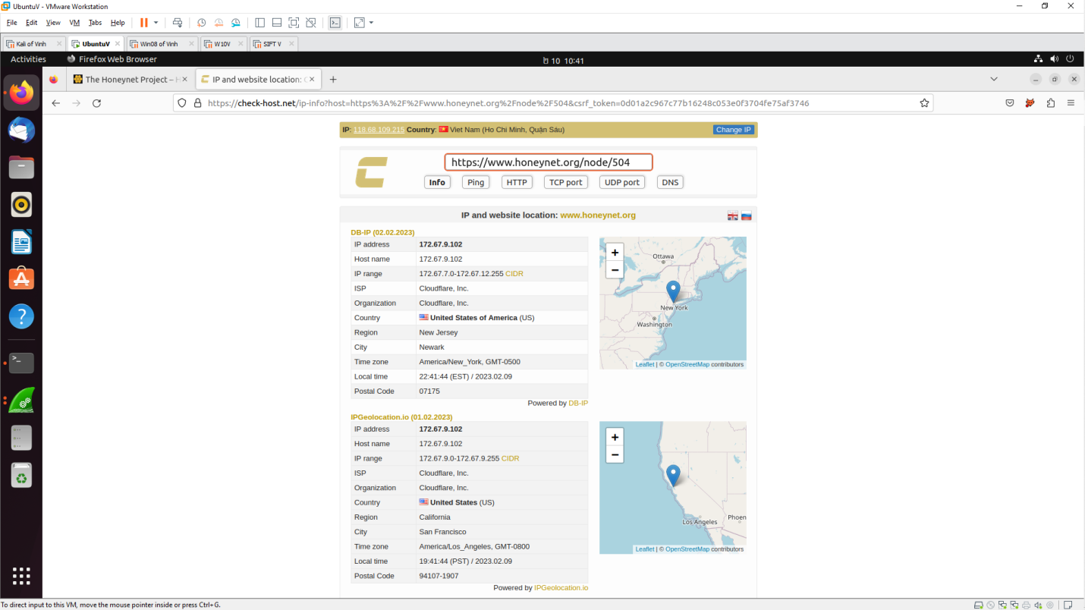

- How many TCP sessions are contained in the dump file?

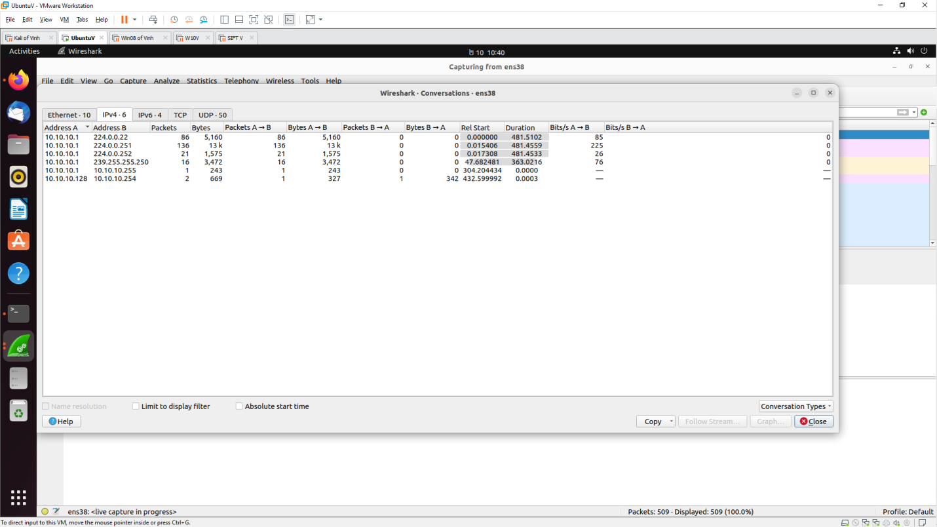

- How long did it take to perform the attack?

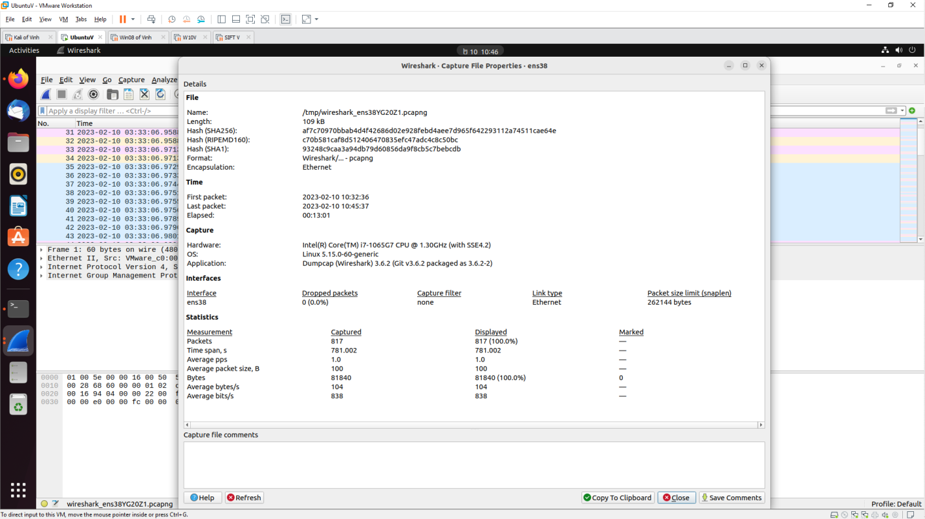

**Install Deep Freeze**

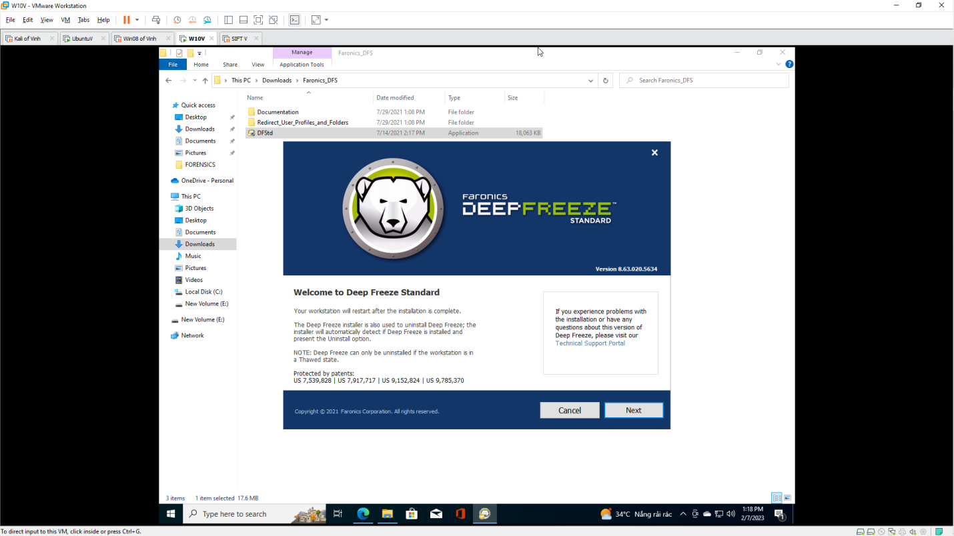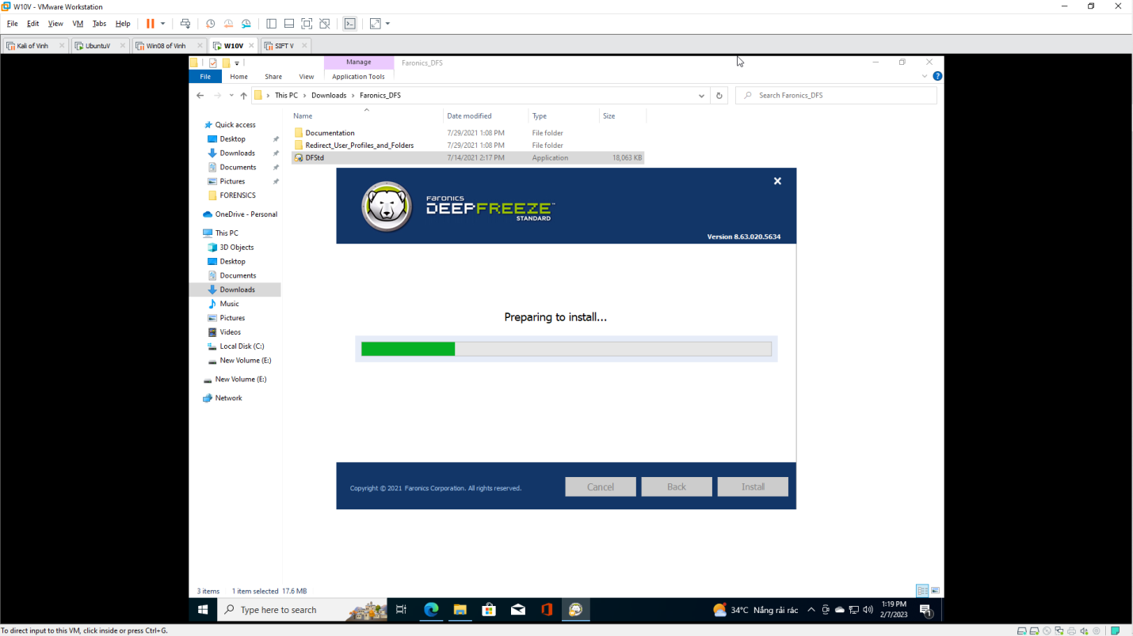

**LAB 7.2: Registry Forensics with RegRipper Plug-ins**

**Purpose:**

• Introduction to the window registry.

• Introduction to RegRipper.

• Analysis of Registry files with RegRipper.

**Download RegRipper**

